1. We will start this course
   1. By learning what is messaging?
   2. What is the advantage of using messaging?
   3. We will do the same with JMS (Java Messaging Service).
      1. We will learn what is JMS?
      2. Then Why we should use JMS to do messaging in our system?
   4. Then we will move on to see the messaging in action while learning the two different styles of messaging
      1. Point to Point.
      2. Pub-Sub.  
           
         We will do the same using JMS 1.X and JMS 2.X APIs.   
         Then we will see how JMS 2.x made our lives earlier by simplifying the APIs.
2. **Anatomy of JMS Message**:
   1. Headers:
   2. Properties:
   3. Payload: Many Types  
      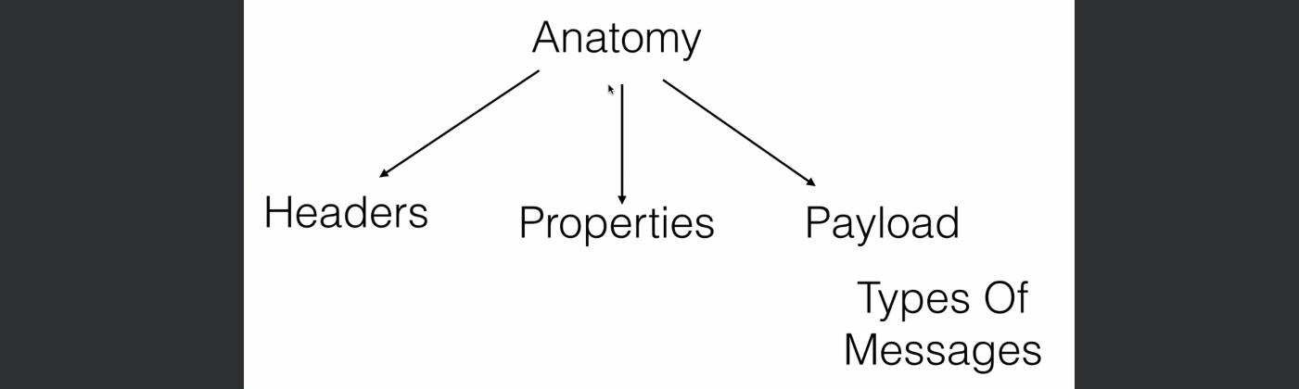
3. We will working on Point to Point and Pub-Sub while working on two tiny little use cases of Hospital management and HR management where we will see load balancer in action and also durable subscription and shared subscription.  
   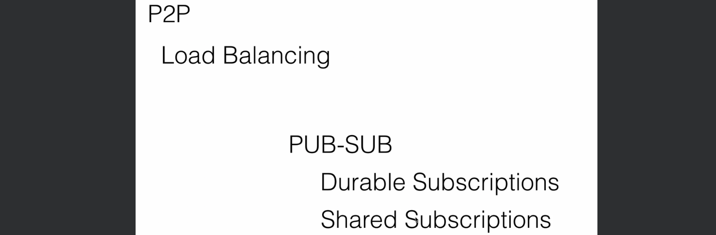
4. 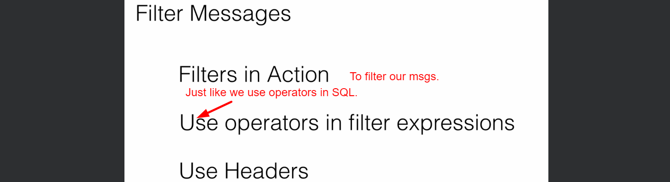
5. Message guarantee is very important for any app.   
   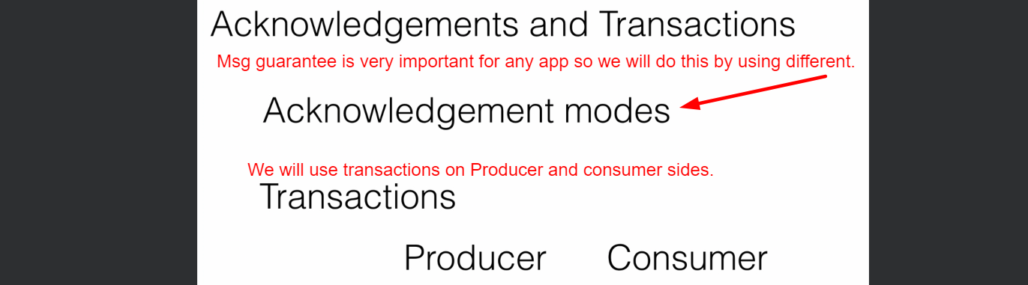
6. 